HackerRank Program 7
Link :- https://www.hackerrank.com/challenges/staircase/problem
Successful Submission
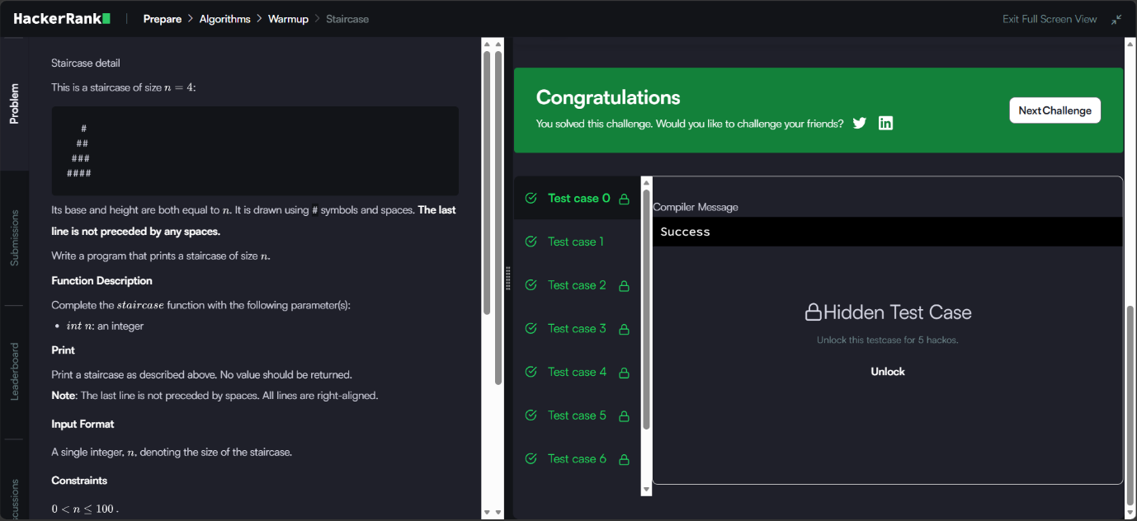
Source Code


